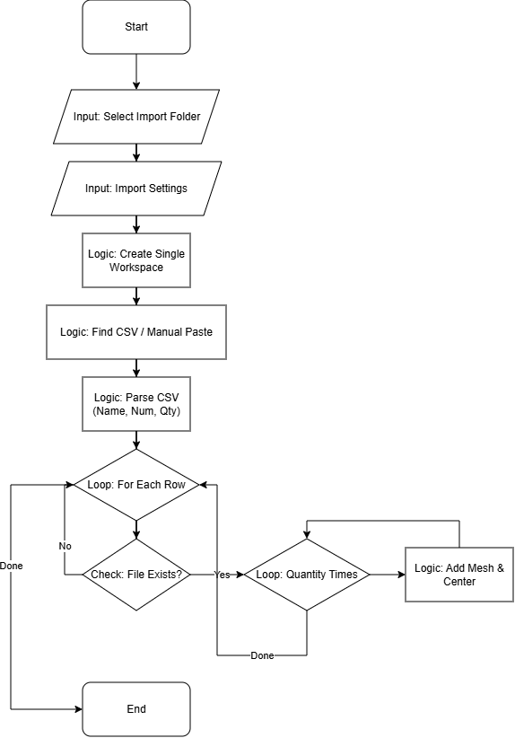
Import Part Quantity Script (MJ)
Script Name: import_part_quantity_MJ.lua

Functionality
This script facilitates the bulk import of parts into a single workspace based on a BOM (Bill of Materials) CSV file. It reads quantities, locates the source files in subdirectories, and imports the exact number of copies required.
Logic Flow:
- CSV Parsing: Reads a CSV file (often via manual paste due to clipboard bugs) containing "Part Name", "Part Number", and "Quantity".
- File Resolution: Constructs file paths dynamically (e.g., [ImportPath]\[PartNumber]\[PartName]). It handles Part Number cleaning by stripping version suffixes (e.g., "-1").
- Consolidation: Creates a single workspace for the entire batch.
- Duplication: Imports each file and creates the specified number of copies, centering them at the origin (0,0,0).

User Guide (Quick Start)
- Prepare your project folder structure (Folders named by Part Number, containing the mesh files).
- Have your CSV ready in Notepad.
- Run the script import_part_quantity_MJ.
- Select the root project folder.
- Set import settings (Deviation, etc.) or accept defaults.
- Manual CSV Input: When the "Manual CSV Import" dialog appears, copy the text from your CSV/Notepad and paste it into the box. Click OK.
- The script will populate the workspace with all parts.

Code Maintenance & Technical Notes
Clipboard/File Read Bug: Netfabb's Lua environment often fails to read files or paste from Excel directly ("Header-only" issues). The script includes a fallback mechanism (`show_manual_csv_dialog`) that forces the user to paste plain text content. Do not remove this fallback.
Single Workspace Strategy: Unlike other scripts, this tool aggregates everything into one tray. Parts are simply centered at the origin, meaning they will overlap. This is intended behavior for initial loading before arrangement.
Path Construction: The script assumes a specific folder structure: Root / CleanedPartNumber / PartName. The "CleanedPartNumber" logic strips suffixes after the last dash (e.g., "OR-123-1" becomes "OR-123"). Modify regex if part numbering changes.

